Research Paper
Title: Integrating Advanced Technology in Aerospace Traffic Management System
Author: Suyanka Pokharel
__________________________________________________________________________
Abstract

The concept of integration in modern aviation refers to the combination of AI, UAVs, and real-time data systems to form a unified management network. In the recent past, emphasis has been put on combining these innovations in such a way that they improve the efficiency and safety of the airspace. Thus, Aerospace Traffic Management (ATM) is required to plan the entire airspace network to make it safe and efficient. ATM is also about managing flight corridors, communication systems, and control systems that will reduce the number of errors and maintain the operations in a well-coordinated condition. Traditional ATM systems are not very responsive to traffic congestion, manual processes, and lack flexibility as the world expands on air travel. This is the reason why AI and other progressive technologies are embraced.

The Unmanned Aerial Vehicles (UAVs), data analytics, and new communication networks (5G/6G) are bringing about the evolution of ATM. The paper suggests the Dynamic UAV Surveillance Model, which is the combination of aerial data of VisDrone, geographical data of OpenStreetMap, simulated UAV flights data and time-dependent traffic data to enhance airspace management and decision making. As demonstrated in the model, UAVs have the ability to autonomously spot, track and carry out other aerial operations with more precision. The findings indicate that new technologies in ATM can be used to create intelligent, green and data-conscious traffic management systems, which are advantageous in the safety, efficiency, and scalability.

Keywords: Integration, Aerospace Traffic Management (ATM), Artificial Intelligence (AI), Unmanned Aerial Vehicles (UAVs), Simulation, Real-time Monitoring, 5G/6G Networks, UAV Surveillance Model.

Table of the Contents

S. No. | Content | Page No.
1 | Introduction | 3-4
1.1 | Problem Statement | 4
2 | Literature Survey | 5-7
3 | Project Description | 4
4 | Implementation Methodology | 7-12
5 | Conclusion | 12-13
6 | Future scope and further enhancement of the project | 13
 | References | 14-15
 | Plagiarism Report (Annexure) | 16

- Introduction
Aerospace traffic management (ATM) is a collection of services that are meant to ensure air traffic is safe, fast and cost effective. It encompasses the whole aviation industry such as aircraft and other air vehicles. Integration in ATM can be translated to a seamless and filtered flow of information between various technologies, systems, and organizations that regulate the flow of aircrafts. The new technological developments have changed the emphasis of merely exchanging data into the integration of intelligent systems capable of carrying out autonomous analytical operations as well as giving adaptive control. The next generation of air-traffic management is being integrated as an umbrella to include AI, UAVs, real time analytics, digital-twin simulations and advanced communication infrastructure systems including 5G and 6G [1].
Conventional ATM systems used to be dependable but currently they are challenged by the growing levels of manned and unmanned flights in the current air space [2]. The aviation sector is expanding around the world, and so is the need to have systems, which have the capacity to dynamically track the traffic, process vast quantities of real-time data and react fast to any alterations in the environment or operations.
In the given case, technology should be utilized to maintain airspace safety, versatility, and environmental friendliness. The advanced digital technologies introduce new ATM features. Flight data are accessed through AI systems to forecast the traffic and point out the conflict areas before they could cause a hazard [4]. Highly-skilled sensors on drones facilitate the surveillance and communication endeavours that humans cannot perceive due to the high density of populated regions or remote locations [2][3].
Digital twins enable operators to model and optimize operations prior to actual execution saving money and minimizing operational risks [4]. Furthermore, the new networks such as 6G, which is still in its development, can share information instantly between land and air systems and thus strengthen the collaboration and quick response in the entire flight operations [4].
Despite the benefits associated with them, the innovations also have their problems that restrain their usage. The challenges like incompatibility of old and new systems, regulatory challenges, security concerns, and high costs are some of the key challenges [3]. The collaboration of the authorities, integrators, and industry players is essential in order to overcome such challenges. Standardization of practice in the aviation sector, regulation reform, and enhanced data protection can help the sector to have a more cohesive and knowledgeable control scenario [5][6].
The presented study examines modern digital technologies and the prospects of how they can be implemented to revolutionize the sphere of aviation traffic operations to ensure the safety, effectiveness, and sustainability of the global aviation industry. The authors believe that the further development of air transport needs modernization of ATM due to its active and continuous development. When properly applied, technology will not only minimize the number of human errors but also boost the airspace and instill a flexible system to the drone flights as well as the pilots [8][9].

- Problem Statement
The air traffic is growing with alarming pace and Unmanned Aerial Vehicles (UAVs) in use have proven to be a significant burden to the existing Aerospace Traffic Management (ATM) systems. The traditional ATM systems have a powerful central control, designed flight strips and manual controls, which limit their responsiveness to dynamic and dense airdrome airspaces. Traffic congestion, slow response time, inability to scale, and high probabilities of human error are therefore continuing to be an issue to the overall system performance.
Moreover, the implementation of new technologies such as Artificial Intelligence (AI) and real-time data analytics and next-generation communication networks (5G/6G) in the ATM systems have not been implemented and integrated fully. Lack of well-integrated system of such technologies causes inefficiency with regard to data sharing, low situational awareness and inability to have safe and efficient airspace operations.
Furthermore, the absence of common principles of integration of UAVs into the controlled airspace only complicates the regulation of the flow, especially when the manned and unmanned planes are used simultaneously in the specific region. This creates difficulties with the real-time monitoring, collision prevention and adaptive control.
- Objective
The principal objective of the work is to examine the possibility of overcoming the existing issues in the field of air traffic management in the aerospace industry with the introduction of cutting-edge technologies. This approach will achieve the following benefits:
- Safety: It helps to make the chances of accidents and collisions less dramatic.
- Efficiency: It streamlines processes, reduces time wastage and maximizes resource utilization.
- Environmental Protection: It is an environment preservation strategy by reducing the fuel usage and emissions.
- Traffic Control: It helps coordinating the aircraft, which pass the airspace without disturbing the safety.
- Customer Experience: It improves the services to the travellers and provides more personalized experiences.

- Literature Review

In recent times, the application of Unmanned Aerial Vehicles (UAVs) has been multiplied and even reaching certain new heights, which are way out of proportion to their application in military. They have rendered a vast expanse of spaces to civil and business purposes including package delivery, high-precision agriculture, environmental surveillance, and disaster management among others [1]. The outcome of this scenario is that there is more sharing of aerial space between manned and unmanned airplanes that has promoted the requirement to coordinate and make flights safer. The current systems that depend greatly on established flying routes, centralized control and communication have to be identified as alternative methods of managing the traffic since they are not quite effective in the light of the flexibility and dynamics of UAVs. To eliminate this problem, a new wave of researchers has begun examining management approaches that are adaptive as well as automated, relying upon artificial intelligence, high-speed communication, and decentralized systems of control as the primary foundation [1][2].
Bauranov and Rakas [1] indicated that the effective and safe operation of the airspace demands consistent situational awareness and effective communication between all the aerial participants to ensure efficiency. In their study, they put a lot of emphasis on secure connections which ensure real time updating between the control centers, the manned aircrafts and the UAVs. They also outlined the introduction of dynamic no fly zones and on demand reconfigurability of airspace so that airspace managers could quickly respond to the change such as emergency, unfavorable weather, or even high traffic. This idea brings ATM to a more flexible, responsive approach that can conform to the real-time situation instead of being preplanned.
In a similar manner, Ma et al. [2] studied the possibility of AI and automation in improving the decision-making process in UAV traffic systems. They discovered that detection of abnormal flight behavior through algorithm use provides a faster solution and reaction time in comparison with human operators, which enhances safety. They also proposed that reinforcement-learning models can be used to enable UAVs to learn the surrounding environment and improve over time their flight behavior in terms of giving them greater autonomy in modifying or adapting to unforeseen circumstances. Nonetheless, Ma et al., also cautioned that there are still some obstacles to overcome, particularly on how AI makes decisions, how data will be kept accurate, and automated systems will be guarded against cyber threats.
One more important issue was considered by Labib et al. [3]: interoperability. They discovered that it is impossible to have UAV networks and normal air traffic control (ATC) operating in harmony unless there are common communication rules. In the absence of these standards, the data sharing will be uneven and less trustworthy, thus complicated cooperation will be hard. They proposed to design universal communication models to ensure that UAVs and ATC can communicate securely and effectively regardless of the system and manufacturer they belong to.
Furthering this premise, Shrestha et al. [4] examined the possibility of the sixth-generation (6G) networks that might assist in controlling UAVs. They described how very high-speed, low-latency networks would be able to provide real-time coordination of large groups of aerial vehicles. By using AI and 6G together, UAVs would be able to handle their routes independently, exchange information and evade collisions more easily. The researchers also observed that such technologies are not only expensive but also involve significant infrastructure to utilize in the global arena. They opined that this would require international collaboration, high investments and high technical requirements.
Labib et al. [3] proposed the idea of Internet of UAVs, an arrangement of UAV communication and control structured into multi-layers. They are structured in such a way that the system is divided into local, regional and global levels.
Local layers provide coordination between UAVs directly, regional layers promote interactions throughout the airspace, and the global layer takes care of policies and other vital decisions. This architecture provides a high level of scalability and resilience through distributed computational and network roles. Design is such that in case of one-layer failure, or too much load, other layers can still carry on with few problems in operation even in regions where there are many UAVs. The articles indicate that the current UAV traffic control primarily relies on three factors: versatile utilization of the airspace, AI-based control, and the communication systems that are rapid and trustworthy.
The transition to decentralized system instead of a centralized one has resulted into real-time coordination of UAVs and their self-management. They are however still faced with numerous challenges that do not allow these systems to be entirely accepted. The key points are cybersecurity threats, incompatibility of old and new systems, and the absence of shared international regulations. The ability to overcome these challenges will only be possible through robust collaboration among engineers, regulators, and policymakers such that safety and growth may progress concurrently.
The study indicates that the air traffic management in the future will be reliant on systems that interact with each other automatically. These systems will incorporate intelligent agents, which have the capability to process information, make decisions and interact without much human supervision. This will minimize the workload required by humans as well as enhancing safety. Nevertheless, the experts recommend such automation entry in controlled airspace should be handled with caution and explicit procedures of testing, checking, and allocating accountability.
To sum up, it is obvious that the introduction of UAVs is taking aerospace management towards an interdependent system relying on data monitoring, machine learning, and rapid communication. As these technologies advance, it will be hard to distinguish between human and automated decisions making. To have secure and fair operations in the airspace, the regulatory bodies should be dynamic with technology and set standards that would make innovation respond to risk control. It will be necessary to work across industry, universities and government to develop the high-tech ATM systems that are smart, flexible and safe. [1-4]
V. Methodology Implementation

The implementation phase is aimed at practical implementation of the proposed Dynamic UAV Surveillance Model through synthesizing various data sets into one analysis framework. The primary goal of this step is to integrate primary data, secondary data, simulation data, and behavioral (temporal) data so that to more efficiently monitor and analyze the state of traffic.

All forms of data serve a different purpose in the system. Primary data gives the visual information that is on the scene which helps in observing the movement of traffic. The secondary data has preset trained models and datasets that help with the object detection. The time-related properties of the data on traffic motion are represented as behavioral or temporal and enable the system to analyze behavioral patterns, including the speed variation and the growth of congestion. Simulation data provides a controlled environment where the system will be tested with safety with the benefit of real-world implementation.

Of these, the role of the simulation data is particularly significant as it enables the proposed model to be tested and verified without putting the real cars or the infrastructure in unconditioned environments that may cause damage. The subsections below describe the application of these various data types in the research.

A. Simulation Data (For Validation and ATM Testing)
The simulation data are taken to replicate the flight and traffic conditions in the real world in a controlled virtual condition. This method has found application especially in aerospace and air traffic studies since real-life experiments may be costly, time-consuming, and unsafe in a few cases. Simulation environments allow different traffic conditions to be created and simulated without any impact on real aircraft or road traffic systems.

In the Dynamic UAV Surveillance Model, a simulation information enables the system to recreate real-life operation situations and test the efficiency of the monitoring system in diverse scenarios. Simulation enables the researcher to see what happens with the UAV-based monitoring systems when the traffic density is varied, when the speed of vehicles is reduced, or when some unusual events are observed.

Simulation too makes it possible to perform several tests within a short period and enhances the reliability and strength of the system before any real-world implementation is taken into account.
There are a number of purposes of simulation data used in this study:
- Evaluation of system robustness: A variety of environmental and operation conditions can be tested by the model.
- Evidencing the functionality of system integration: UAV monitoring, AI detection and analytics modules can work in a simulated ATM environment.
- Scalability evaluation: The system can be tested based on various traffic density degrees to find out whether the system can provide greater monitoring activities.

B. Relevance to Research

In UAV research, simulation is also important since complex systems can be experimented in a safe and controlled setting. The performance of UAV can be analyzed by researchers under various conditions without the use of costly real-life equipment or extensive field experimentations.

Simulation will be useful in this research to enhance the validity of the suggested monitoring model prior to its implementation in practical situations. It enables the replication, analysis of various airspace and traffic situations without any additional risks associated with safety rules or cost of operation.

The study integrates the use of UAV technology, data analytics, and communication systems into a simulated environment and proves how air traffic monitoring systems could become smarter, more adaptable, and data-oriented. The knowledge acquired during simulation experiments is a solid basis of additional design and implementation in aerospace traffic management systems.

C. Primary and Secondary Data (Practical Implementation)

Despite the fact that big data (e.g., VisDrone) is very helpful in the training of detection models, it may demand huge computational resources to construct experimental systems. Thus, the actual implementation of the suggested model was implemented more efficiently.

This study relies on an object detection model that has been trained in advance and real-world video data, instead of training an entirely new model.

Primary Data:

The main dataset on which the tests will be conducted is a high-resolution aerial video that is 30 seconds long and captures highway traffic. This video will be used as a real-world test environment where the system will be in a position to observe and analyse the movement of vehicles in a real traffic environment.

Secondary Data (Foundational Model):

The system has adopted the YOLOv8n (Nano) object detector model that is already trained over the COCO data set. Since this model already knows the common objects (cars, buses, and trucks) it can enable the system to undertake detection functions within a short time with high level of efficiency without involving more large-scale training.A lightweight pre-trained model will make sure that the monitoring system is computationally efficient and at the same time have the capability to detect and track the vehicles accurately.

System Architecture and Implementation

The system is made out to be a multi-stage processing pipeline, which takes the raw aerial video data and transforms them into actionable traffic insights. It has a processing and decision-making architecture that enables the system to examine the traffic conditions in real-time.

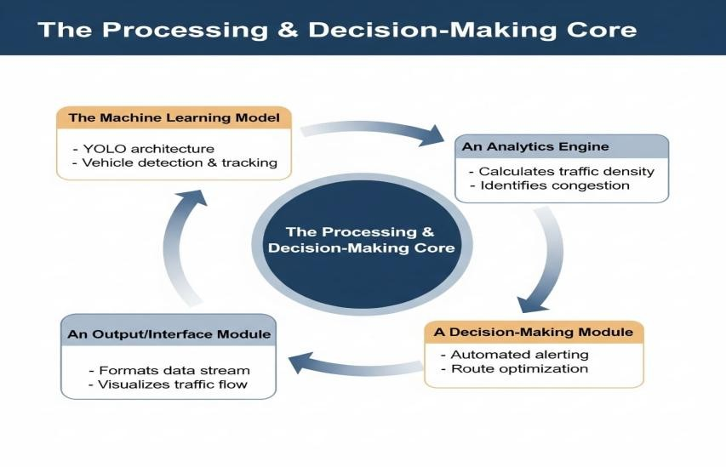

Figure 1: The Processing & Decision-Making Core

The architecture has four key modules:
- Machine Learning Model: This is in charge of identifying and monitoring cars on the video frames.
- Analytics Engine: The data on the tracking is processed and traffic metrics are calculated (vehicle speed and congestion levels are considered).
- Decision-Making Module: Compares the calculated measures to detect unusual traffic conditions or situations.
- Output Module: Documents the system notifications and damage of discovered events.
The modules are continuously interconnected to process raw visual data into useful traffic information that can be used to support the process of monitoring and decision-making.

V.A. The Machine Learning Model

The YOLOv8n ("Nano) model serves as the fundamental detection engine to make sure that the processing is fast and efficient. YOLO models have been popular due to real-time object detection features and hence can be used with traffic surveillance applications.
This model is integrated to the ByteTrack tracking algorithm that gives each vehicle detected a unique identifying number that they carry throughout their life. This enables the system to track individual vehicles in a variety of frames and determine their pattern of movement and speed.

V.B. The Analytics Engine (Real-Time Analysis)

The analytics engine is code written in Python and OpenCV and operates the tracking data produced by the detection model.
Speed Calculation:
The video was calibrated with pixels per meter ratio to estimate vehicle speed in real world units. The traffic lane was 3.7 meters in size and had 125 pixels in the video frame, which gave a conversion ratio of 33.78 pixels per meter. This ratio will also enable the system to transform the pixel movement into real-life speed measurements in terms of kilometres per hour.
Anomaly Detection:
Based on the behaviour of the vehicles, the system detects the irregular events. As an example, a STOPPED VEHICLE anomaly occurs when the speed of a vehicle is below 1 km/h over a duration of over one second.
Congestion Detection:
There is a particular congestion monitoring zone, which is located in the highway area. When a vehicle or vehicles within this zone are observed to be traveling at a speed below 10km/h, a CONGESTION DETECTED alert would be triggered by the system.

V.C. The Decision-Making and Output Module

All the events that are detected are recorded in a CSV log file in the decision-making module which keeps up a time-stamped record of traffic alerts. Moreover, the system produces visually based products including annotated video recording and image snapshots that indicate the observed traffic events.

These outputs give the researcher and the operator an opportunity to analyze the behavior of traffic in a better way since they offer both numerical data and visual indication of the identified anomalies.

  - Results and Discussion
The system was then run on a Google Colab T4 GPU on a 30-second test video and the system took around 2 minutes to run around 900 frames. The model was able to identify several vehicles and trace them in the video. With the YOLOv8n model and the use of ByteTrack, the system was capable of tracking vehicles in the same way and analyzing their motion in time.

The findings indicate that the system is capable of detecting traffic occurrences like stoppage and congestion depending on the pre-programmed conditions. The emitters of alerts were correct and could be logged with timestamps and the visual confirmation of the annotated outputs was clear. In general, the system shows good reliability of the performance of the system in the real-time monitoring of the traffic though there can be some fluctuations under the complex traffic or poor video condition.

Table 1: Sample of Generated Alert Log
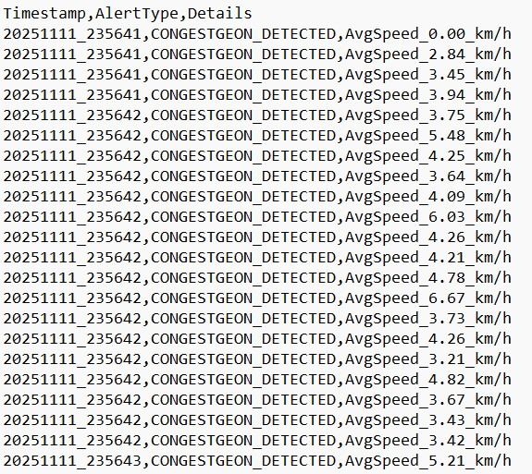

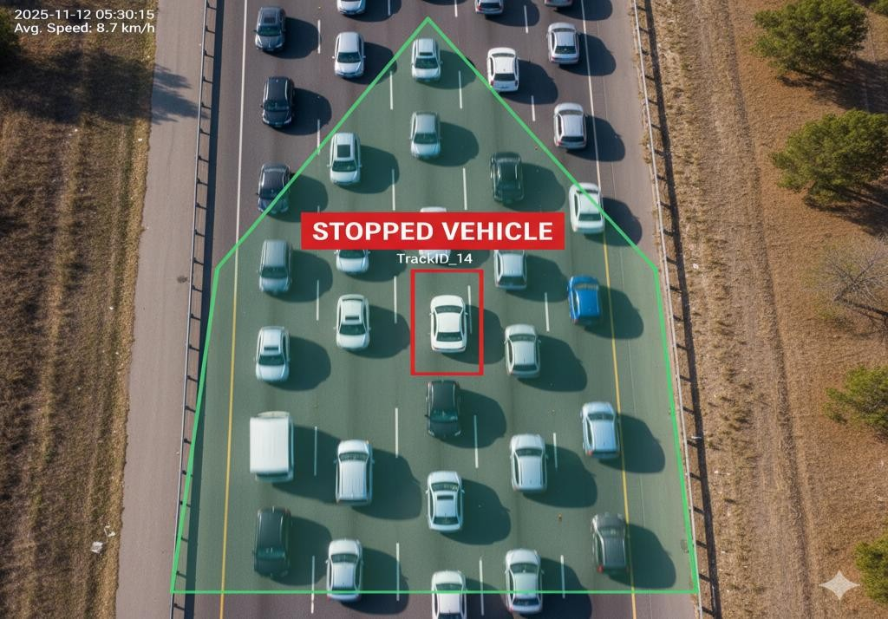
Figure 3: System identifying a 'STOPPED VEHICLE' anomaly.

Conclusion for the diagram part

The outcomes of the diagram indicate that the system can effectively identify and point out abnormal traffic conditions such as a stalled vehicle in a traffic jam. Although the base model is lightweight, the system still ensures good performance in tracking automobiles and detecting major events in real time.

The synergy between the AI detection model and the analytics engine furnishes such useful pieces of information as the speed and congestion rates that enable one to better comprehend traffic behaviour. This illustrates that the system would be able to accommodate effective monitoring and decision making within high traffic settings.

  - Conclusion

This paper examined how traffic observation systems and management systems can be improved through artificial intelligence and UAV-based monitoring. The suggested Dynamic UAV Surveillance Model is a hybrid of a light AI detection model and a tailored analytics engine to identify vehicles, monitor their movement, and determine traffic phenomenon, such as congestion and vehicles that are stopped. The system is capable of analyzing aerial traffic footage through the use of the YOLOv8n model and real-time video processing and provides useful insights based on the obtained data.

The experimental results indicate that the system has the capability of detecting the behaviour of traffic and producing alerts about abnormal conditions in a relatively short period of processing time. Although using a lightweight model, the system was capable of object detection and tracking with good results, showing that it is possible to create practical and scalable solutions without the use of very complex computing sources.

This study presents the increased importance of intelligent technologies in the innovation of the contemporary Aerospace Traffic Management (ATM) systems. With the rise of the number of aerial vehicles and drones, automated monitoring technologies will gain significance in enhancing the safety and aiding decision-making. Altogether, the combination of UAV surveillance, AI, and real-time analytics can be used to achieve smarter and more efficient traffic management systems.

  - Future Work

Even though the results of the proposed system are promising, there are a number of improvements that can be pursued in future studies.

The first way to improve the situation is to optimize the YOLOv8n model on specialized aerial data, like VisDrone. The reliability of the model to identify vehicles and traffic behaviour may be enhanced by training the model with additional aerial traffic data.

The second improvement that can be made is the utilization of more than one UAV to cover more space. A drone network would have a greater range and cover more areas, as well as enabling the system to monitor traffic conditions in various locations.

There might also be the incorporation of newer communication technologies in the future like 5G and the 6G network. These technologies would enable the UAVs to relay information faster to the ground stations enhancing real time monitoring and decision making.

Also, more complex traffic conditions could be tested on the system in more advanced simulation environments prior to being deployed in the real world. Predictive analytics might also be applied in the future to predict traffic jams or to identify abnormal behavior early and enable the development of safer and efficient aerospace traffic management systems.

References

[1] Bauranov, A. and Rakas, J., 2021. Designing airspace for urban air mobility: A review of concepts and approaches. Progress in Aerospace Sciences, 125, p.100726.

[2] Ma, Q., Zhang, Z. and Song, W., 2020. Automation and AI in air traffic control: Real-time monitoring and management. IEEE Transactions on Intelligent Transportation Systems, 21(9), pp.3683–3693.

[3] Samir Labib, N., Danoy, G., Musial, J., Brust, M.R. and Bouvry, P., 2019. Internet of unmanned aerial vehicles—A multilayer low-altitude airspace model for distributed UAV traffic management. Sensors, 19(21), p.4779.

[4] Shrestha, R., Bajracharya, R. and Kim, S., 2021. 6G enabled unmanned aerial vehicle traffic management: A perspective. IEEE Access, 9, pp.91119-91136.

[5] Caverly, D.C., Peterson, C.L. and Delaney, C.J., 2008. Technology integration. In Handbook of college reading and study strategy research (pp. 334-370). Routledge.

[6] Digital Adoption, “What is Technology Integration?” Available: https://www.digital-adoption.com/glossary/technology-integration/. Accessed: Feb. 7, 2025.

[7] SKYbrary, “Air Traffic Management (ATM),” Available: https://skybrary.aero/articles/air-traffic-management-atm. Accessed: Feb. 7, 2025.

[8] Ertürk, M.C., Hosseini, N., Jamal, H., Şahin, A., Matolak, D. and Haque, J., 2020, September. Requirements and technologies towards uam: Communication, navigation, and surveillance. In 2020 Integrated Communications Navigation and Surveillance Conference (ICNS) (pp. 2C2-1). IEEE.

[9] Raza, W., Renkhoff, J., Ogirimah, O., Bawa, G.K. and Stansbury, R.S., 2025. Advanced air mobility: Innovations, applications, challenges, and future potential. Journal of Air Transportation, 33(2), pp.169-187.

[10] Kopardekar, P., Rios, J., Prevot, T., Johnson, M., Jung, J. and Robinson, J.E., 2016, June. Unmanned aircraft system traffic management (UTM) concept of operations. In AIAA Aviation Forum and Exposition (No. ARC-E-DAA-TN32838).

[11] Clothier, R.A., Greer, D.A., Greer, D.G. and Mehta, A.M., 2015. Risk perception and the public acceptance of drones. Risk analysis, 35(6), pp.1167-1183.

[12] Dorling, K., Heinrichs, J., Messier, G.G. and Magierowski, S., 2016. Vehicle routing problems for drone delivery. IEEE Transactions on Systems, Man, and Cybernetics: Systems, 47(1), pp.70-85.

Plagiarism Report (Annexure)

